|  |
| --- |
| PS2Win |
| Weekly Report |
| Keep Your Time |

|  |
| --- |
| Filipe Brandão  03-06-2013 |

**Team Members:**

Carla Machado

David João

Filipe Brandão

João Girão

João Martins

Mário Oliveira

Rui Ganhoto

**Week 15**, 27th of May to 3th of June

Content

1. Week Activities 1

1.1. Work Executed 1

1.2. Work Analyses 1

1.3. Achievements 1

2. Impediments 1

3. Plans For Next Weeks 1

4. Progress 2

4.1. Earned value and/or Gantt Image 2

4.2. Effort by task 3

4.3. Individual effort 3

5. Individual log 4

**Images**

Figure 1: Earned Value 2

Figure 2: Week effort by task type 3

Figure 3: Week effort by team member 3

**Tables**

Table 1: List of Contributors ii

Table 2: Version history ii

Table 3: Log of individual effort 4

|  |  |  |  |
| --- | --- | --- | --- |
| **Authors and Contributors** | | | |
| **Date** | **Name** | **Contacts** | **Contribution** |
| 03-06-2013 | Filipe Brandão | a21180276@alunos.isec.pt | Author |
| 03-06-2013 | Mário Oliveira | a21170292@alunos.isec.pt | Contributor |
| 03-06-2013 | Carla Machado | a21170460@alunos.isec.pt | Contributor |
| 17-06-2013 | Rui Ganhoto | a21170262@alunos.isec.pt | Contributor |
|  |  |  |  |

Table 1: List of Contributors

|  |  |  |  |  |  |
| --- | --- | --- | --- | --- | --- |
| **Revision History** | | | | | |
| **Date** | **Description** | **Author** | **Version** | **Approvers** | **State** |
| 03-06-2013 | Creation of first draft | Filipe Brandão | 0.1 |  | Draft |
| 03-06-2013 | Changing Sate | Filipe Brandão | 0.1 |  | Ready for Revision |
| 03-06-2013 | Document reviewed | Mário Oliveira | 0.1 |  | Ready for Revision |
| 03-06-2013 | Corrections | Filipe Brandão | 0.2 |  | Ready for Revision |
| 03-06-2013 | Changing State | Filipe Brandão | 0.2 |  | Ready for Approval |
| 03-06-2013 | Some comments and suggestions on alterations.  Approved |  | 0.2 | Carla Machado | Ready for approval |
| 17-06-2013 | Approved |  | 0.2 | Rui Ganhoto | Ready for Approval |
| 27-06-2013 | Changing State | Filipe Brandão | 1.0 |  | Baselined |
|  |  |  |  |  |  |
|  |  |  |  |  |  |

Table 2: Version history

# Week Activities

# Work Executed

* Meeting to prepare a plan for the last week
* Code Inspection – Follow-up
* Finished all the coding tasks
* Execution of the test plan and defects correction

# Work Analyses

Due to bad indicators in the EV analysis done last week, this week started with a meeting between all the members to obtain information regarding the project progress and to prepare a plan for the last week. This helped us to finish the project on time. It also helped in reducing the stress and misgiving in the team.

The priority was to, first, finish all the coding tasks, then approve the test plan (ignoring the Document Management Process) and then execute it as it is. During the coding tasks, the Technical Manager was really finishing all the details.

# Achievements

* Coding phase finished
* Test plan executed and some of the defects found were corrected

# Impediments

Although there were members that did not complete the 6 hours of work, the test plan was not reviewed, corrected and approved as the process defines. This happened because the duration of these tasks would certainly take longer than a week and that the plan for the last week prioritized the coding tasks.

# Plans For Next Weeks

* Prepare the final presentation.
* Correct bugs in the Earned value or create a new one, validate presented values

# Progress

# Earned value and/or Gantt Image

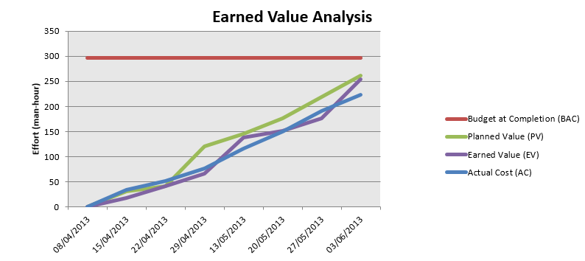

Figure 1: Earned Value

Planned Value = 262h

Earned Value = 254h

Actual Cost = 223h

A new bug was found in the EV: if all tasks are marked as complete, the Earned Value reaches 267h (+5 than the Planned Value).

# Effort by task

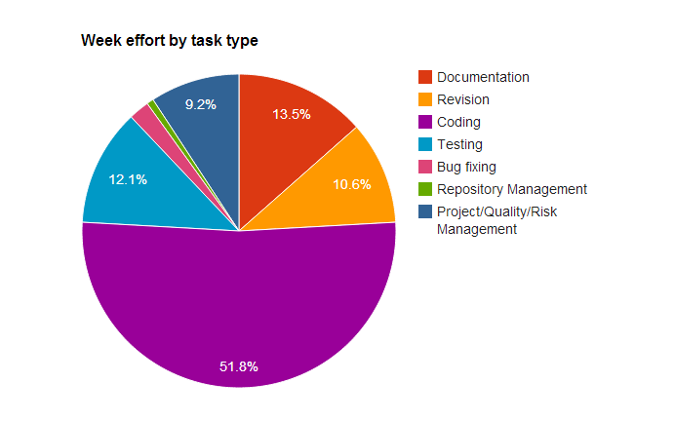

Figure 2: Week effort by task type

# Individual effort

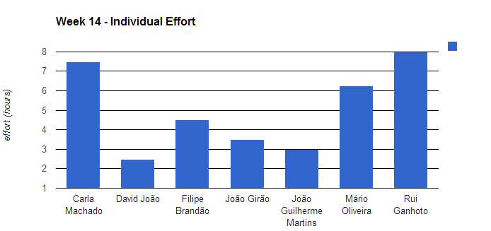

Figure 3: Week effort by team member

|  |  |
| --- | --- |
| **Name** | **Effort(hours)** |
| Carla Machado | 7.5 |
| David João | 2.5 |
| Filipe Brandão | 4.5 |
| João Girão | 3.5 |
| João Guilherme Martins | 3 |
| Mário Oliveira | 6.25 |
| Rui Ganhoto | 8 |

Table 3: Log of individual effort

# Individual log

**Carla Machado - Tasks done:**

* Edit Task 2.25h
* Approval of weekly report 0.25h
* Review of meeting minute 0.25h
* Approval of test plan 2h
* Writing of next week meeting agenda 0.25h
* Test execution 1.25h
* Bug Fixing 0.75h
* Validation of issues 0.5h

**David João - Tasks done:**

* Finalizing Shortcuts configuration UI and some code 0.5h
* Corrections to test plan 1.25h
* Some corrections and bug fixing to shortcuts and other random things 0.75h

**Filipe Brandão - Tasks done:**

* Creation of a prioritized task list 0.5h
* Approving Test Plan 1h
* Fixing Logs and Dashboard 0.5h
* Test plan execution 1h
* Fixing 0.5h
* Validation of the corrections to failed tests 0.5h
* Weekly Report 0.5h

**João Girão - Tasks done:**

* Task Details UI, Functionality and Integration 0.5h
* Execution of performance and interface tests 1.5h
* Creation of the Tests Measures document 1.25h
* help in task list 0.25h

**João Martins – Tasks done:**

* Test plan last details 0.5 h
* Settings code fix 1h
* Follow up 1.5h

**Mário Oliveira - Tasks done:**

* Revision of weekly report - Week 12 0.25h
* Update repository 0.25h
* Task list - Delete task 0.5h
* Task list - show stop date , today and total time 2.5h
* Task list - stop date (date/hour) 0.75h
* Task list - stop and play button 2h

**Rui Ganhoto - Tasks done:**

* Weekly Report Approval 0.25h
* Task list For Priority Purposes and Contingency Plan 0.5h
* Meeting Minutes Resume 0.5h
* Resume Task Development 0.75h
* Shortcuts Detection Development 0.5h
* Shortcuts Development 0.75h
* Improvements in Task and Time Database Adapters 0.5h
* Changing Buttons on Current Task Selected 0.5h
* Minor Corrections In Task List Components 0.5h
* AutoComplete Corrections 0.75h
* Interface Improvements 1h
* Inactivity Corrections 1h
* Failed tests Corrections 0.5h